Partnerships For A Skilled Workforce

Knowledge Innovation Economy

Metro Southwest . . . Technology Heartland of Massachusetts

Covering the area between Routes 128/I495, and serving 43 communities, Metro Southwest is one of the largest of the 16 workforce regions in Massachusetts.
The Metro Southwest (MSW) region contains communities that are defined by high-growth, high-paying knowledge and innovation industries, exceptional educational attainment and outstanding research and education institutions.
MSW is a college labor market in which jobs requiring post-secondary education dominate and college-educated residents thrive. Those without post-secondary education do not.

The Great Recession and the Recovery

MSW employment level exceeds employment at the beginning of the recession

MSW lost 3.3% jobs in the Great Recession, while job loss in the state as a whole was 4.0%.
MSW had the strongest growth among all state’s regional labor markets, increasing 2.6% between the fourth quarters of 2009 and 2010.
In the first quarter of 2008, there were 468,967 jobs in the region. In the third quarter of 2013, employment at 496,153 exceeded 2008 employment.

Like the state as a whole, the recovery has spanned industries

EMPLOYMENT IN KEY METRO SOUTHWEST INDUSTRY SUPERSECTORS
Industry | Q1/2008 | Q2/2013 | % Difference
Scientific Research & Development | 9,837 | 12,129 | 23.3%
Computer Systems Design | 19,425 | 23,809 | 22.6%
Health Care | 45,708 | 52,814 | 15.5%
Professional & Technical Services | 66,422 | 67,569 | 1.7%
Telecommunications | 1,788 | 2,589 | 44.8%
Manufacturing | 55,564 | 51,929 | 6.5%

Job vacancies rates rising

The job vacancy rate in Greater Boston was 3.4% at the end of 2007, declining by more than a percentage point at the end of 2009 and rising to near 3.0% as the economy recovered. Greater Boston has 45% of employment, but 55% of the vacancies across the state.

In the fourth quarter of 2010, the most recent data available, the total vacancies in Greater Boston were 42,880. The largest numbers were in sales, 8,798; office and administrative support, 4,737; business and financial operations, 4,079, computer and mathematical jobs, 4,092; management, 3,562; and food preparation and serving, 3,917.

Unemployment remains the lowest in the state, but almost 40% experience long periods of joblessness

The unemployment rate in MSW jumped to 6.5% during the recession, up from 3% in 2007—the lowest among all workforce regions in the state.
The MSW rate increased over the past year—from 5.2% in June 2012 to 5.8% in June 2013, still well below the state rate of 7.4%.
In June 2013, 29,413 people were unemployed, an increase of 3,205 over the past year—11% of the state’s unemployed.
In July 2013, 37.0% of the unemployed had been unemployed for 27 weeks or longer. The average weekly spell of unemployment was slightly over 36 weeks. The median was 15.7 weeks.

The unemployed in MSW were older and more educated than the unemployed in the state as a whole
One-third of the unemployed have a high school diploma or less, compared to one-half in the state. However, as a consequence of the highly educated workforce in MSW, 46.7% of the unemployed in MSW have a bachelor’s degree or higher, substantially higher than the 22.8% statewide.

Youth did not fare well in the recession
17.5% of the unemployed are ages 16 to 24, but they are only 9.5% of the workforce. However, youth unemployment in Metro Southwest is significantly below the state as a whole. 26.4% of the unemployed in the state are between the ages of 16 and 24.

Population

Without the influx of immigrants, the population in MSW would have declined over the past decade

At 1,038,784 residents, MSW accounted for 16.6% of the state’s population at the end of 2010, behind the Southeast (21%) and Boston/Metro North (19.2%)
After experiencing the second fastest population growth rate (0.4%) early in the decade, MSW was one of only three regions to experience a decline in population in recent years—0.1%.
From 877,860 in 2000, the native born population fell to 859,444 in 2010, while the immigrant population grew by 2.7% to 179,340 in 2010.
In the period 2000–2007, the growth of working-age immigrants was 3.6%, larger than in Massachusetts at 2.8% and in the United States at 3.2%. Immigration slowed in 2010 to 1.5%, less than in Massachusetts at 2.0% and in the United States at 2.3%.
The region became more ethnically and racially diverse over the decade, with a 6.3% increase in the number of Hispanic and a 5.2% increase in Asian residents.

Income Sufficiency

MSW is a high-income region, but not all individuals share in the prosperity

From 2007 to 2011, the average median household income was $79,691 in Middlesex County and $83,733 in Norfolk County, well above $65,981 in Massachusetts.
For the same time period, per capita income in Norfolk County was $43,685 and $41,453 in Middlesex County compared to the state per capita income of $35,051.
7.7% of the population in Middlesex County and 6.3% of the population in Norfolk County fell at or below the federal poverty level (the federal government defines poverty as $15,510 for a family of two up to $39,630 for a family of 8) compared to 10.7% of the residents in the state.
Youth poverty rates for 15 to 24 year olds in Metro Southwest range from 16.6% in Brookline, 11.5% in Waltham, 7.8% in Framingham to 0/0% in Dover. The average poverty rate for all 43 cities and towns is 4.9%.

The MSW Labor Market: Demand

Second largest labor market in the state
MSW is the second largest labor market in the state with 16.7% of the state’s employment or 552,952 jobs and 14.6% of the labor force at 508,257 labor market participants.

Almost three quarters of the jobs are in education and health services, trade, professional and business services, and manufacturing

One-third of Massachusetts knowledge technology jobs are in Metro Southwest

Firms with 100 or more employees accounted for almost one half of the jobs in MSW
The majority of companies (87.6%) had fewer than 20 employees, but they accounted for only 22.4% of employment.

200 companies employ 250 or more employees
1,000-4,999 Employees | 500-999 Employees | 250–499 Employees
First Fidelity | Agilent Technologies | ACI Worldwide, Inc.
Invensys North America | Compushare Investor Services | Avery Dennison Corporation
Mitre Corporation | Digital Federal Credit Union | Bloomingdale's
Novell Inc. | New England Center for Children | Boston Mutual Life Insurance
Sun Capital Advisors | PAREXEL International Corporation | Cognex Corporation
TJX Company, Inc. | Roche Brothers | Dialogic, Inc.

MSW Labor Market: Supply

MSW is a net importer of workers
MSW is a net importer of workers with 60,000 more employees commuting into the region for work than residents commuting out.

Labor force growth slowed by 2010
Between 2000 and 2005, the labor force grew by 4.6%, compared to Massachusetts 4.4% and the United States 4.8%. By 2010 the growth rate of the MSW labor force slowed to 2.2%, less than that of Massachusetts, 3.0% and the United States, 3.2%.

MSW has the oldest workforce in the Commonwealth

Slightly over 50% of the unemployed in MSW are 45 or older, compared to 36.6% in the state.
Between 2000 and 2010, the number of 45–64 year olds in the workforce in MSW increased by 5.6%; 16–24 year olds increased 1.8%. The prime working age group, 25–44 year olds, declined by 4.5%.

Best educated workforce in the Commonwealth

80% of MSW workers had completed some post-secondary education by the end of the decade, compared to 70% in Massachusetts and 60% in the nation.
Nearly 30% of MSW’s workers had a master’s degree or higher, almost double the share of workers in Massachusetts with a master’s.
The number of people in the labor force in the region without a high school diploma or GED fell by 2.0% to 29,248 in 2010.
46.7% of the unemployed in MSW have a bachelor’s or higher, compared to 22.8% in the state.
Educational attainment falls sharply by age cohort. The largest potential shortfall is in associate’s degrees; 12,600 people in MSW between 45 and 54 have an associate’s degree. Fewer than 5,000 people between the ages of 25 and 34 have an associate’s.

The 128 loop encompasses 58 institutions of higher education—18 in Metro Southwest.

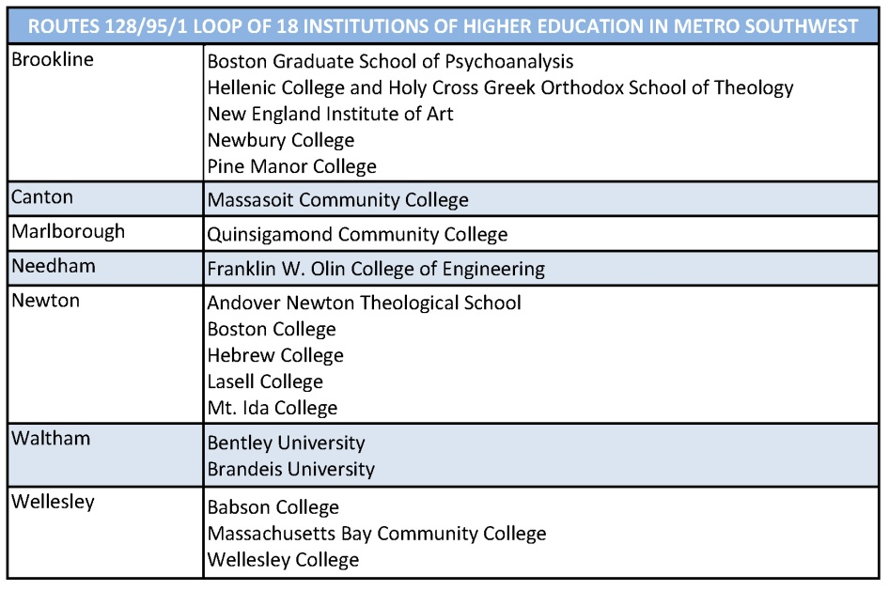

MSW is home to 44 secondary school districts
In addition to the 40 “comprehensive” high schools, there are four regional career technical schools schools—Minuteman in Lexington, Tri-County in Franklin, Blue Hills in Canton and Joseph P. Keefe in Framingham.

Health Care

In the second quarter of 2013, ambulatory care made up 48.9% of the 52,814 health care jobs in MSW
Hospitals include medical, surgical, psychiatric and substance abuse hospitals.
Ambulatory care includes doctor’s and dentist’s offices, medical and diagnostic labs and home health care.
Nursing and residential care include nursing homes, residential mental health facilities, and community care facilities for the elderly.

Occupational distributions vary by health care subsectors

Health care practitioners and technicians make up 40% of the ambulatory care workforce compared to 50% of the hospital workforce and 20% of the nursing and residential care workforce.

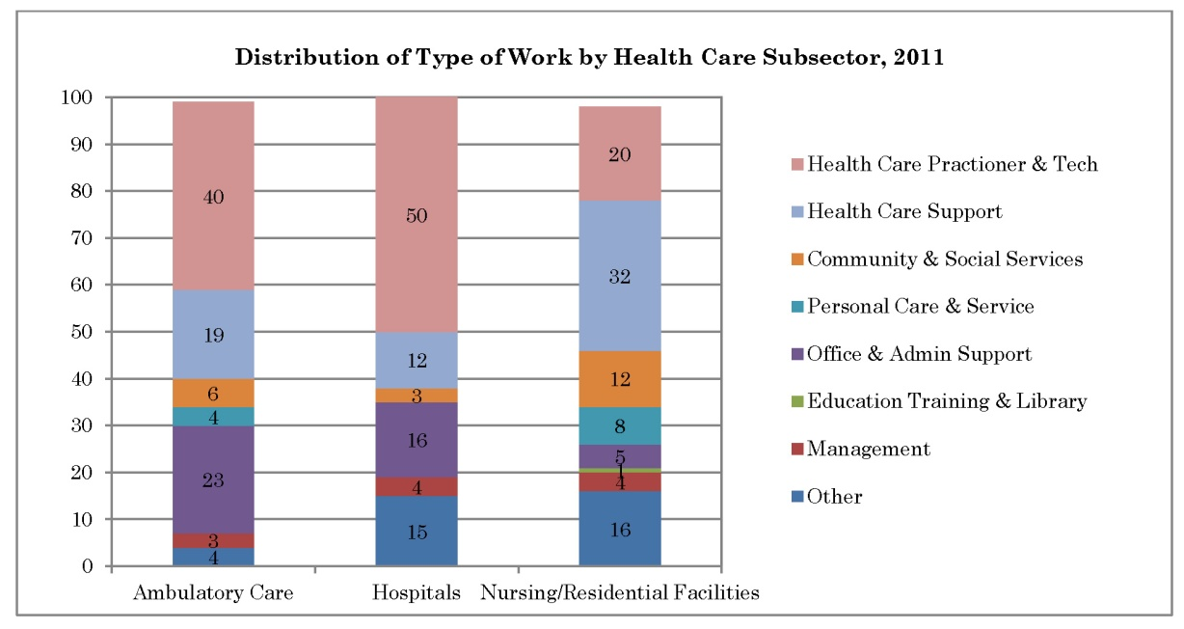

78% of the health care jobs do not require a bachelor’s degree.

These percentages do not sum to 100 because the occupations requiring a Doctorate are omitted.

Health care jobs are a pathway to economic self-sufficiency

Salaries range from $22,430 for jobs not requiring a post-secondary degree (pharmacy aide) to $89,960 for jobs requiring a master’s degree (physician assistant).

Average Annual Salaries by Achievement
Education Requirement | Salary Range
No post-secondary education requirement | $22,430–$47,480
Certificate required | $28,480–$47,480
Associate's degree | $35,160–$67,200
Bachelor's degree | $37,710–$86,450
Master's degree | $35,940–$89,960

Advanced Manufacturing

The majority of MSW manufacturing firms fit the definition of “advanced manufacturing”

Advanced Manufacturing
Innovate, turning raw materials into complex products
Compete with high standards, not low wages, in design, production, delivery and product life cycle management
Pay well for a highly skilled workforce
Participate in a network of scientists, researchers, precision machinists, engineers, financiers, business developers and entrepreneurs
Believe that the network is the strength of innovation and problem solving

Three of the top manufacturing industries in MSW, computers, electronics and pharmaceuticals are classified as “high tech” by the Organization for Economic Cooperation and Development. (The classification is based on the products produced .)

Manufacturing accounts for almost one in ten jobs in MSW

MSW manufacturing firms employed 51,929 workers in the second quarter of 2013, down from 55,564 in the first quarter of 2008.
67% of the almost 700 employers surveyed across the state in 2011 reported moderate or severe shortages in skilled production (machinists, craft workers and technicians). Only 8% reported difficulty filling entry-level jobs, down from 43% in 2008.
MSW firms report difficulty in filling R&D engineer, chemist and other highly educated specialist jobs.
Eleven of the 25 largest medical device companies in the Commonwealth are located in MSW

Largest Medical Device Companies In msw
Thermo Fisher Scientific | Nova Biomedical Corporation
Boston Scientific | HartWare International
Alere, Inc. | Tegra Medical
PerkinElmer | Tanika Therapeutics, Inc.
Hologic, Inc. | TEI Biosciences, Inc.
Insulet Corporation

Manufacturing firms in MSW hire a greater proportion of professional and technical workers than manufacturing firms in other regions of Massachusetts

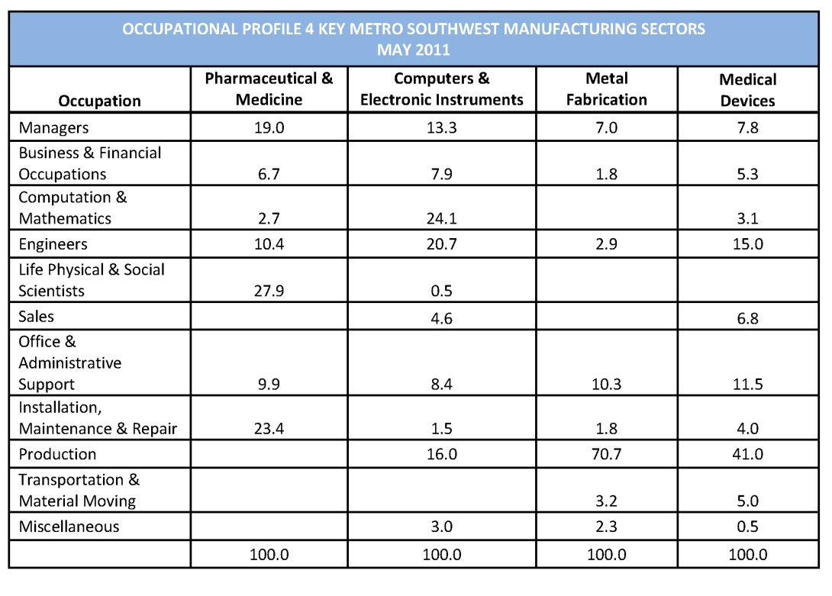
Manufacturing workers in MSW are well paid

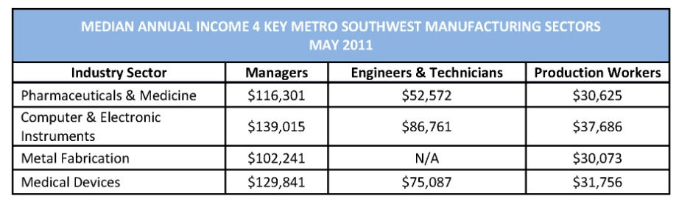

The majority of manufacturing workers in MSW are well educated
In 2010, 21.9% of MSW workers had some college or an associate’s degree. 52.9% had a bachelor’s or higher.

Information Technology

Four subsectors make up the Massachusetts IT industry

Massachusetts Information Technology Sectors & Subsectors
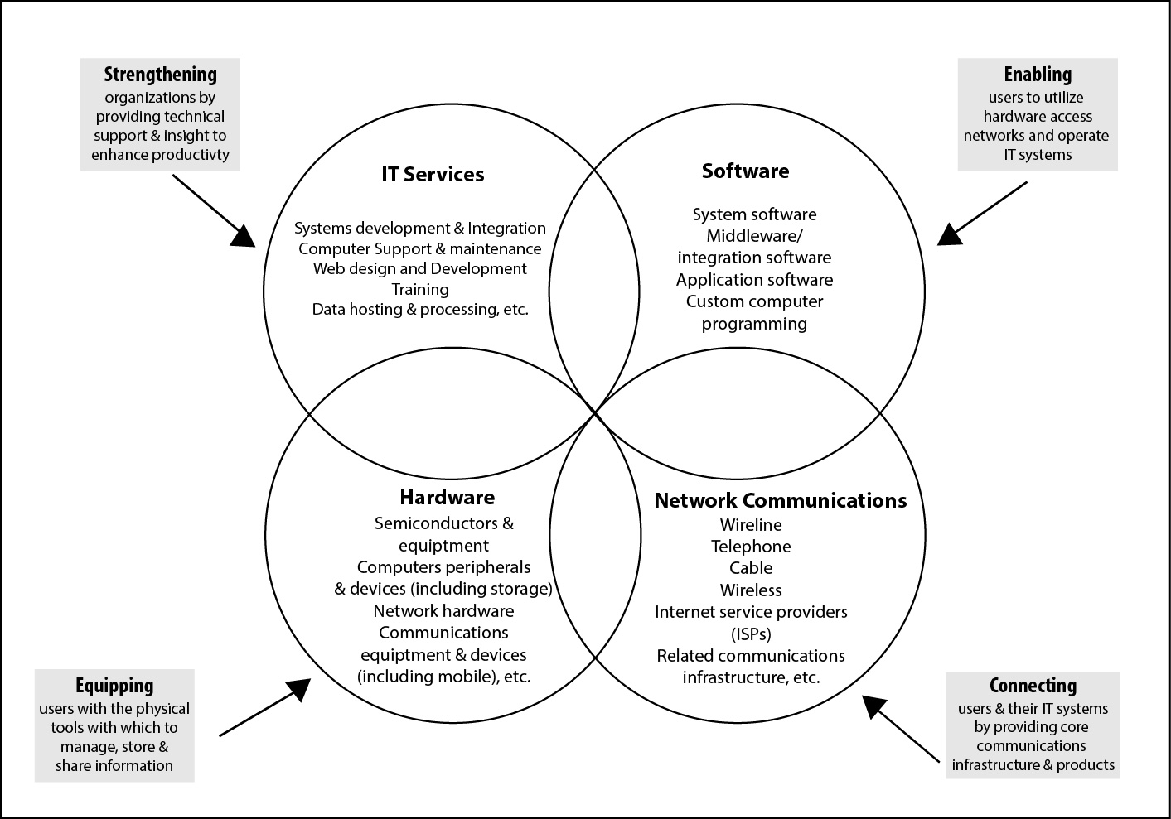

IT has moved from hardware development and production to IT services and software over the decade

In 2000, almost 40% of the jobs were in the hardware sector. By 2008 only 32% of the jobs were in hardware. 54.5% of the jobs are now in IT services and software, up from 45.6% in 2000.

21 of the 70 fastest growing companies ranked by revenue growth between 2009 and 2012 were in information technology firms. Five were in MSW.

5 Fastest Growing Tech firms in msw
EchoStor Technologies
Emservop
Solidas Technical Solutions
Syrinx Consulting Corporation
NWN Corporation

Although reduced in size since 2000, IT is still a significant presence in the Commonwealth and in MSW
At its height in 2000, IT firms statewide employed over 240,000 people. In 2008, that number had shrunk to 178,322.
In the third quarter of 2012 there were 27,291 information jobs in MSW, slightly over five percent of all jobs in the region.

There is opportunity for workers with some post-secondary education, but not a bachelor’s degree—middle skills jobs

In 2011, there were 153,560 IT middle skills job openings statewide.

IT middle skills jobs in massachusetts
Computer Network & Database System Administrators | 32,610
IT & User Support | 24,732
Web–Internet–Digital Media | 21,541
Data & Information Management | 20,093
Demand for software developers for network/computer systems is expected to rise by 71.7% between 2010 and 2020.

Software Developer Growth Areas
Java/j2EE/Java Developer | SAP
Mobile | SharePoint
NET | Web Developer
Software Developers | Network Engineers
Security | Networking Cloud 900

IT industry salaries are higher than salaries in other industries in Massachusetts
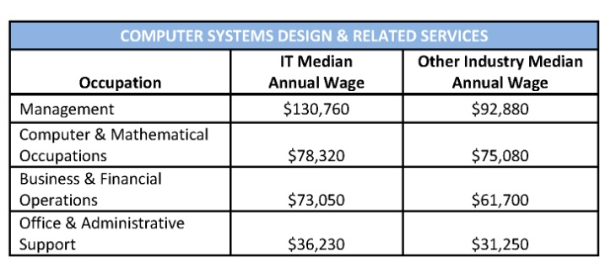
The median salary for software developers specializing in systems design was $94,570 in 2011. Software application developers were not far behind at $88,120, while computer systems analysts had a 2011 median salary of $82,160.

Challenges Ahead

With a diverse industry base and a well-educated workforce the region is well positioned to thrive over the next decade. However, there are significant challenges facing policy makers, educators and workforce development organizations. Actions must be taken to:
- Ensure that there are an adequate number of people in the workforce by supporting the growth of jobs that are attractive and accessible to people who left the workforce during the recession and maximize the potential of the immigrant population

- Create a job-driven education and training system that re-skills those who are currently unemployed and prepares the workforce of the future by strengthening working relationships between business, industry and education at all levels
- Dramatically expand opportunities for all young people to work and learn through co-op programs, internships and paid work

Clifford, Robert. Labor Market Trends in the Metro South/West Region. Commonwealth Corporation and the New England Public Policy Center of the Federal Reserve Bank of Boston. Boston, MA. June 2012. p. 21.
Clifford, 21.
Massachusetts Executive Office of Labor and Workforce Development (EOLWD).
Clifford, 39.
Clifford, 40.
Clifford, 17.
EOLWD.
EOLWD
Bureau of Labor Statistics, US Department of Labor. Economic News Release. Unemployed persons by duration of unemployment. July 2013.
Clifford, 19
Clifford, 18.
Clifford, 8.
Clifford, 8–9.
Clifford, 9.
Clifford, 10.
Clifford, 9.
US Census Bureau. Quick Facts. 2011.
US Census Bureau, Quick Facts. 2011.
US Census Bureau. Quick Facts. 2011.
Clifford, 21
EOLWD. Annual Profile for Metro South/West Workforce Area. May 2010.
Clifford, 20
Clifford, 11.
Clifford, 18.
Clifford, 9.
Clifford, 15.
Clifford, 15.
Clifford, 15.
Clifford, 15.
Clifford, 16.
Wikipedia. List of colleges and universities in metropolitan Boston.
EOLWD.
Clifford, 33.
Blakely and White, 26.
Blakely and White, 27-31.
Deloitte Consulting LLP. Reexamining advanced manufacturing in a networked world: Prospects for a resurgence in New England. The New England Council. December 2009.
Bluestone. 36. Thomas Hatzichronoglou, “Revision of the High-Technology Sector and Product Classification.” Paris: Organization for Economic Cooperation and Development.
EOLWD.
EOLWD.
Bluestone, Barry, Anna Gartsman, Don Walsh, Russ Eckel, and James Huessy. Staying Power II: A Report Card on Manufacturing in Massachusetts. The Kitty and Michael Dukakis Center for Urban and Regional Policy, School of Public Policy and Urban Affairs, Northeastern University. Boston, MA. 2012.
Beville, Sylvia, Kelley French. Manufacturing in Metro Southwest. Partnerships for a Skilled Workforce. Marlborough, MA. 2013.
Boston Business Journal. August 16022, 2013.
Clifford, 33.
Clifford, 28.
Goodman.
Goodman.
Boston Business Journal. Area’s Fastest-Growing Private Companies. April 26, 2013.
Goodman.
BATEC. An Analysis of Information Technology Middle Skill Job Openings 2011. Boston, MA. June 2012.
Boston Business Journal, August 2-8, 2013.
Boston Business Journal, August 2-8, 2013.
Boston Business Journal, August 2-8, 2013.

